SAFETY and INFECTION CONTROL:
- Hazardous materials should be stored in locked cabinet
- Training should be given before using new equipment
- Basic Emergency response may furnish short term recovery, however long-term recovery may take much longer. Review the info on Basic Emergency response
- Be able to distinguish between
  - Body mechanics and ergonomic programs
    - Recognize the examples of each
  - Patient safety and healthcare professional safety guidelines (review the power points)
- Requesting assistance when moving a patient may reduce the likelihood of injury.
- Review the fire extinguisher classes and what kind of fires they can be used on.
- Know what an MSDS is and when it might be needed
- When handling liquids, read the label at least 3 times before using it.
- Understand the roles of agencies in safety and infection control:
  - EPA
  - CDC
  - FDA
  - OSHA
  - Joint Commission
- Identify when you might see the following:

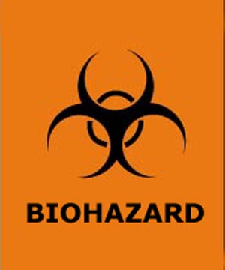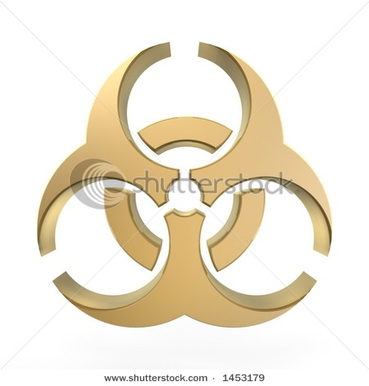

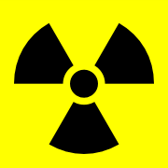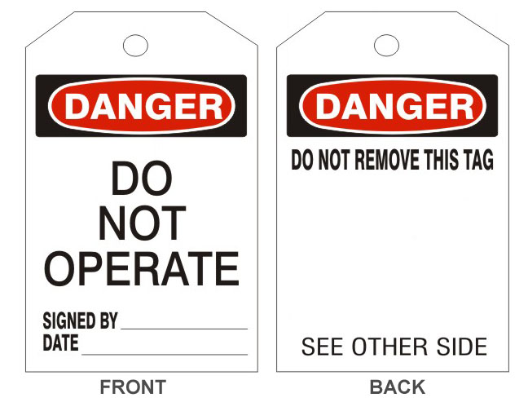
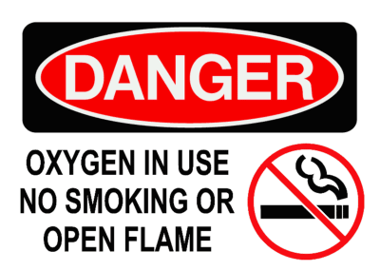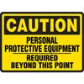
- Know the infection control terms on the handout in packet and the following:
  - Normal flora consists of non-pathogens
  - Chain of infection
  - Direct contact vs indirect contact transmission
  - Anerobic vs aerobic mircoorganisms
  - Local vs systemic infections
  - Nosocomial infections (what is the best prevention for these?)
  - Endogenous vs exogenous infections
  - Protozoan breeding area is by water
  - Rickettsiae is and infectious disease caused by the bite of fleas, ticks, lice (often found in wooded areas)
  - Staphylococci infections require good hand washing and gloves to be worn by hospital workers
  - Fungal infections often result in a rash
- Review the 3 levels of asepsis and the indications for each
  - Antisepsis
  - Disinfection
  - Sterilization (kills spores and viruses, best for medical instrumentation)
- Standard precautions and Blood borne pathogens
  - Contact
  - Airborne
  - Droplet
  - Reverse
- Treatment for bacterial infections: Antibiotics
- AIDS has no cure. It is treated with antivirals meds (AZT).
- Vaccinations are a way to control the spread of microorganisms

