HS2 Exam Review 2: Safety and Wellness Name ___________________________

1. Basic emergency response is taking immediate actions to:
2. What is wellness?
3. What are the 5 elements of wellness? Describe each.
4. Identify and describe the 3 steps to basic emergency response
5. What are the 3 factors to remember when responding to an emergency situation?
6. What is the definition of body mechanics?
7. Why is it important to use proper body mechanics?
8. What practices promote wellness?
9. There are 8 rules for proper body mechanics, what are they?
10. As relating to the medical field, what does environmental safety refer to?
11. Why is it important to read policy and procedure manuals?
12. True or False: It is a good idea to get training before operating new equipment, but not always necessary.
13. What should you do if you see an unsafe situation?
14. How does good nutrition promote wellness?
15. What are 3 safety tips for handling liquids?
16. What health screenings and examinations help to promote wellness?
17. Where can you find information on any chemical used in the workplace (write out what the acronym stand for)?
18. What information is contained in the page discussed in question 17?
19. How does physical activity promote wellness?
20. How does stress management promote wellness?
21. What are the 3 needs of a fire?
22. What genetic factors can have an impact on wellness?
23. What are the 4 A’s of stress management?

Match the following signs/symbols with the appropriate statement

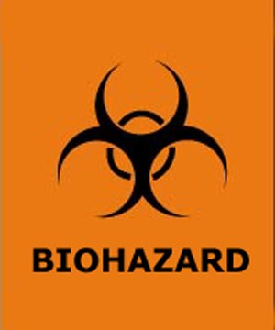



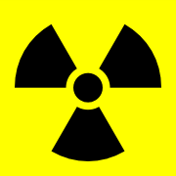



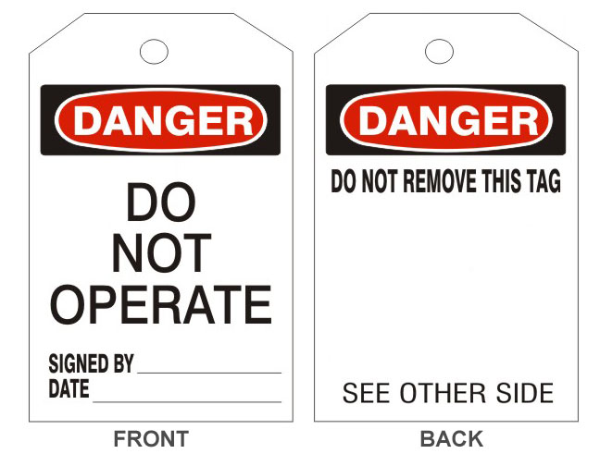



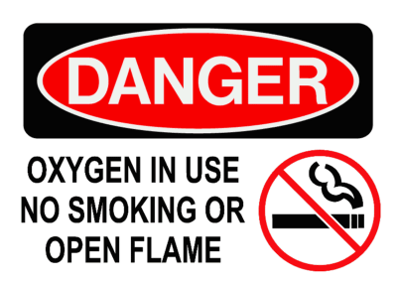



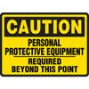

1. ____ 1) This sign is placed in areas that are highly contaminated and should only be entered by trained individuals who are wearing the proper equipment  
     
   ____ 2) This sign indicates an area in which compressed oxygen is being used. No smoking or open flames should be present in these areas.  
     
   ____ 3) This sign is found near radiation treatment or x-ray facilities  
     
   ____ 4) This sign is used on damaged or dangerous equipment  
     
   ____ 5) Materials marked with this symbol may be contaminated or contain infectious pathogens  
     
   ____ 6) This sign indicates which type of personal protective equipment must be worn before entering a specific area. Can also indicate specific safety hazard

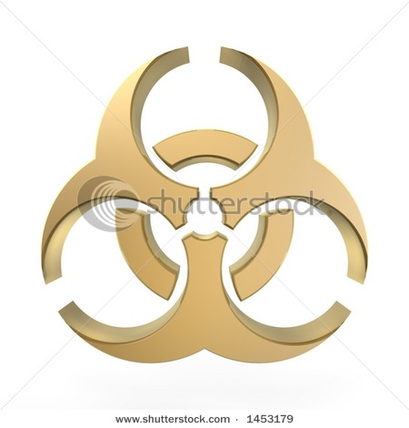

1. In the event of a spill, what would you need to do?
2. List 4 self-destructive behaviors that affect wellness.
3. Identify the 5 types of fire extinguishers and explain what type of fire each one would be used on.
4. What are 5 ways to reduce stress?
5. What does the acronym ‘RACE’ mean in relation to fire safety?
6. List 3 environmental factors that affect wellness.
7. What should you do if you are exposed to blood or other body fluids while working in a healthcare setting?
8. What does the acronym ‘PASS’ mean in relation to fire extinguisher use?
9. List 5 fire prevention strategies discussed in class.
10. How would you tend to a person who has a piece of glass stuck in their eye? Eye exposed to a chemical?
11. What are the 7 healthcare professional safety strategies discussed in class?
12. What are 5 keys to maintaining patient safety?
13. Identify the 6 regulatory agencies that relate to safety. Explain how each one relates to safety.