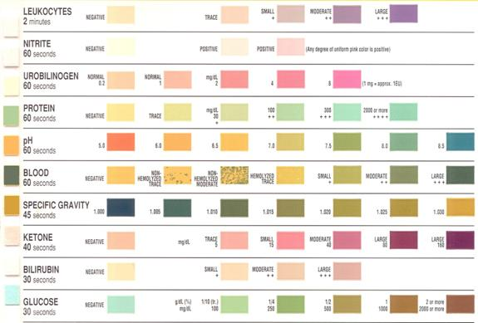

What do the results indicate?
- Abnormal Acidity levels (pH): may indicate kidney or urinary tract disorder
- Specific gravity (SG): shows how concentrated your urine is. Higher levels indicate low fluid intake
- Protein: high levels indicate kidney problems
- Sugar: normally low in urine. High levels may indicate diabetes, further testing is indicated
- Ketones: should not be present in urine. Presence indicates probable diabetes, further testing indicated
- Bilirubin: product of RBC breakdown that is normally processed in liver. Presence of bilirubin in urine may indicate liver disease or damage
- Nitrites / leukocytes: both are byproducts of WBCs. If present in urine, it may suggest UTI.
- Blood: if present in urine, may mean kidney damage, infection, kidney stones or bladder stones, bladder cancer or blood disorders.

